Chapter 7, Problem 90.

An attenuator probe employed with oscilloscopes was designed to reduce the magnitude of the input voltage v_{i} by a factor of 10. As shown in Fig. 7.149, the oscilloscope has internal resistance R_{s} and capacitance C_{s}, while the probe has an internal resistance R_{p}. If R_{p} is fixed at 6 MΩ, find R_{s} and C_{s} for the circuit to have a time constant of 15 μ s.

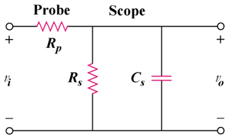

Figure 7.149
For Prob. 7.90.

